FRESH COAST
NEWARK RESTAURANT WEEK

Pre-Fix Lunch Menu

California Bowl
Maui Wawi Bowl
Chicken Teriyaki Bowl
Tofu Gotcha Bowl
24 oz Bowl + bottle of water…………………………...$ 10.00

16 oz Acai + 1 Choice of Drizzle…………………………$ 10.00

16 oz Smoothies (Regular)…………………………………$ 5.00
12 oz Juices……………………………………………………….$ 5.00
16 oz Lemonade + 1 Choice of Fruit…………………..$ 3.00
FRESH COAST
NEWARK RESTAURANT WEEK

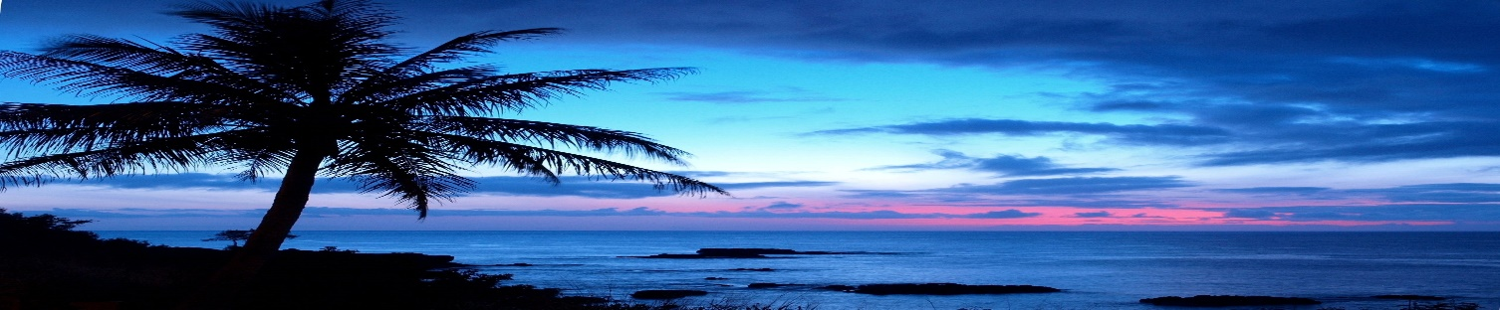

Pre-Fix DINNER Menu

California Bowl
Maui Wawi Bowl
Chicken Teriyaki Bowl
Tofu Gotcha Bowl
32 oz Bowl + Lemonade…………………………………....$ 15.00

16 oz Acai + 1 Choice of Drizzle…………………………$ 10.00

16 oz Smoothies (Regular)…………………………………$ 5.00
12 oz Juices……………………………………………………….$ 5.00
16 oz Lemonade + 1 Choice of Fruit…………………..$ 3.00

